**CSH Science Research Program Internship Information Meeting**

**Link to presentation:** <https://goo.gl/4xxDq7>

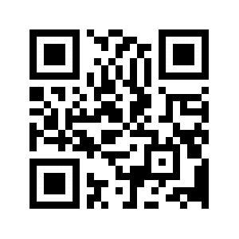

**List of Local Research Internship Opportunities**

**2018-2019**

|  |  |
| --- | --- |
| **Stony Brook University**  *Simons Summer Research Program*  <https://www.stonybrook.edu/simons/>  Deadline January 18, 2019  Current junior  Must be 16 at start of program  3 nominees per school  Application via school | **Feinstein Institute for Medical Research** *Summer Student Intern Program*  <https://www.feinsteininstitute.org/education-careers/education/student-intern-programs/>  Deadline January 18, 2109  Must be 16 by July 1, 2019  Individual applies |
| **Stony Brook University**  *Garcia Research Summer Program*  <https://www.stonybrook.edu/commcms/garcia/summer-highschool-program/info.html>  Deadline February 17, 2019*  Must be 16 within 1 week of start of program  Minimum 3.8 unweighted GPA  Individual applies | **Rockefeller University**  *Summer Science Research Program*  <https://www.rockefeller.edu/outreach/lab-initiative/summer-science/>  Deadline December 3, 2018  Must be 16 at start of program  Individual applies |
| **New York University**  *Girls' Science, Technology, Engineering, and Mathematics Summer Program*  <https://cims.nyu.edu/gstem/>  Deadline March 22, 2019  Females only  Junior but exceptional sophomores considered  Individual applies | **Brookhaven National Laboratory**  *High School Research Program*  <https://www.bnl.gov/education/program.asp?q=219>  Deadline March 22, 2019  Recommended for current Juniors  Must be 15 at start of program  Individual applies |
| **Cooper Union**  *Summer STEM Program*  <https://cooper.edu/engineering/summer-stem>  Deadline March 9, 2019*  Junior but exceptional sophomores considered  Individual applies | **Hofstra University**  *Summer Science Research Program*  <https://www.hofstra.edu/academics/colleges/hclas/sse/sse-applications.html>  Deadline March 31, 2019*  Sophomores and juniors  Individual applies |
| **Cold Spring Harbor Laboratory**  *Partners For the Future Program*  <https://www.cshl.edu/education/partners-for-the-future/>  Deadline April 6, 2019*  3 nominees per school  Current junior  Possibility of starting in the summer |  |